Prayer of St. Patrick as sung by Rita Connolly

I arise today
Through the strength of heaven.
Light of Sun
Radiance of moon
Splendor of fire
Speed of Lightening
Swiftness of wind
Depth of the sea
Stability of Earth
Firmness of Rock.

I arise today
Through God’s strength to pilot me
God’s eye to look before me
God’s wisdom to guide me
God’s way to lie before me
God’s shield to protect me
From all that shall wish me ill
Afar and anear
Alone and in a multitude
Against every cruel merciless power
That may oppose my body and soul

Christ before me
Christ behind me
Christ on my right
Christ on my left
Christ above me
Christ below me
Christ within me
Christ in the mouth of everyone that speaks to me
Christ in the eyes of everyone who sees me
Christ in the ears of everyone who hears me
Christ in the heart of everyone who thinks of me

I arise today.

(And proclaim to everyone and everything
The Christ in me greets the Christ in you
The Christ in me greets the Christ in you
Namaste)

Let us pray for new birthings in our own lives, for one another, for our communities, for our nations and the world.

In the beginning, O God,
your spirit swept over the chaotic deep like a wild wind
and creation was born.
In the turbulence of my own life
and the unsettled waters of the world today
let there be new birthings of your Spirit.
In the currents of my own heart
and the upheavals of the world today
let there be new birthings of your mighty Spirit.
-Celtic Benediction, John Philip Newell

Celtic Spirituality № 12: Pilgrimages awaken the journey of life.
Andy Atwood
Follow
6 min read
·Oct 16, 2025

My brother and me climbing up Mt. Washington
In Celtic Christianity, going on a pilgrimage isn’t just about reaching a holy destination — it’s about stepping into a landscape where the veil between the seen and unseen grows thin.
Liminal spaces, thresholds… steps into the unknown… all were highly valued by the Celts.
For our son’s 10th birthday, he and I hiked up Mount Washington in New Hampshire. That was in 1990. My second hike up was for his son’s 10th birthday, and that was in 2012.
The journey, though challenging, was then — as it always is — well worth it.
The Celts believed the Divine was woven into creation itself — into stones, streams, wind, and wild places. While not named as such, theirs was a panentheistic faith (everything exists in God, but God is more than everything).
So, a pilgrimage was less about leaving home and more about entering deeper into reality.
Unlike the medieval or modern concept of pilgrimage as a trip to a fixed “holy site,” the Celtic tradition emphasized journeying with presence and intention — to open one’s eyes to the sacred that is already near.
For the Celts that sometimes meant going to remote islands like Iona where solitude and the elements stripped away distractions.
Sometimes it was as simple as walking to a local well, mountain, or ancient tree.

My One-Friday-A-Month journey to the Hermitage in Three Rivers, Michigan.
I had heard the call, but the normal distractions of home and work kept me from stepping forth. That was until I made my first journey to the Hermitage in 1986.

The Hermitage in Three Rivers, MI
When I first arrived for a one-day silent retreat, I knew I was in the right place. I was greeted by a private room in St. Joseph’s Barn, meals offered in silence, forest and field to walk, and books and sacred artifacts to stimulate my spirit.
For five years I would go one Friday a month. I would meet people in between visits and invite them to come along for their own silent retreat. Not in five years did anyone ever say no.
Henri J. M. Nouwen wrote that the first movement of the spiritual life is from loneliness to solitude — the work of becoming at home with yourself.
Three times I spent the first weekend of the new year in The Hut. It was named La Verna after the place that was St. Francis’ personal retreat. In the snow I trekked out to this little building.
Press enter or click to view image in full size

Press enter or click to view image in full size
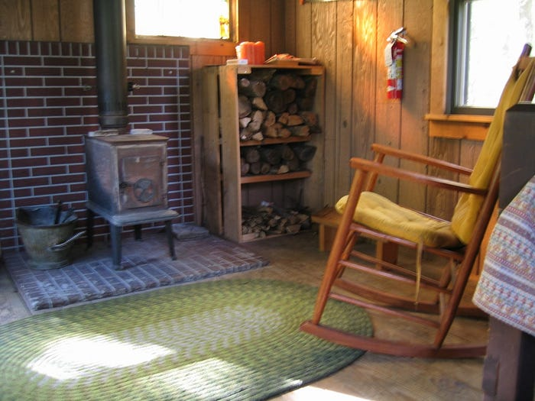
There in that room, with only an oil lamp at night and a little fire for warmth, did I sit in solitude.

In the Celtic tradition, a pilgrimage held three integrated purposes.
First, it was for an encounter — stepping out of ordinary life and moving into mystery… to meet the Divine at the edge of life, at the threshold of nothingness.
Second, a pilgrimage was about being transformed — losing one’s ego and finding one’s soul.
Third, it was about finding one’s place within all of Divine creation. Belonging. Deep and pervasive belonging to the entire Universe.
After my retreat days I would, quite naturally, return home to family and work… but little by little, not as the same person.

1992 — A week at the Abbey of Gethsemani in Trappist, Kentucky.
Eventually, I needed something more profound to happen to me. So off I went to the motherhouse of the Trappist monasteries in the United States, and the home of Thomas Merton.
Press enter or click to view image in full size
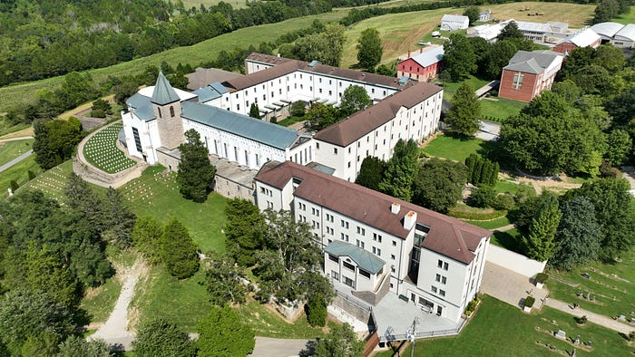
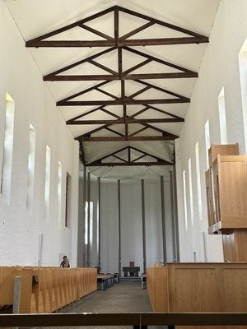
While there, I arose for the 3:15 a.m. Vigils… and then for the seventh time of the day at 7:30 p.m. for Compline. Seven times, following the ancient Benedictine rule, did I gather with the monks in the chapel for prayers and chants.

I also walked the paths through the forest to the statues.
I passed Peter, John, and James… asleep.
Press enter or click to view image in full size
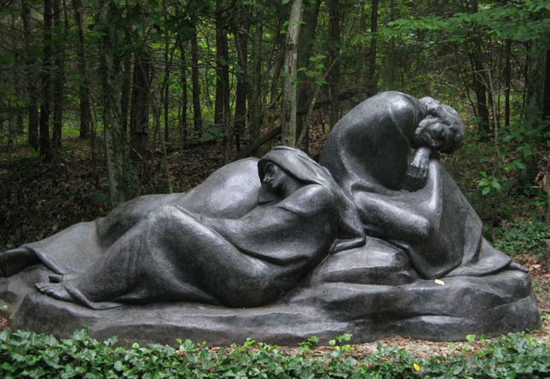
And then further down a path, I came upon Jesus in the Garden of Gethsemani.
Press enter or click to view image in full size
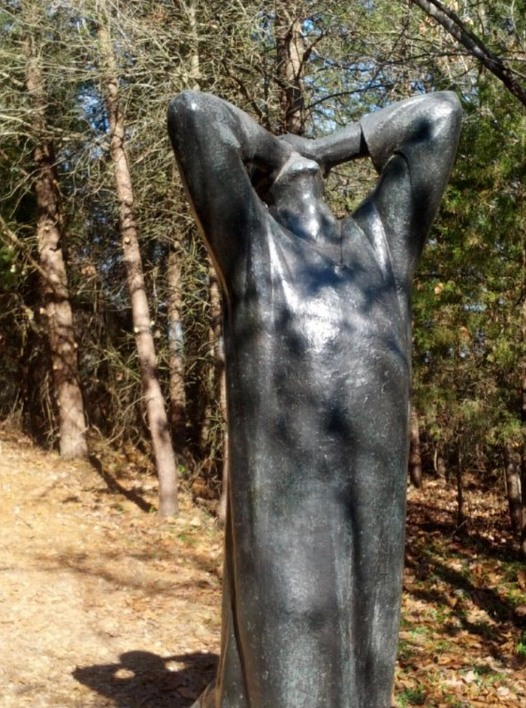
These visits to the Hermitage, to the Hut, to the Abbey, were all intentional movements out of my ordinary life — and having done so, I was refreshed and reborn in ways that stuck with me, more or less.
During the fall season after my visit to the Abbey, our family acquired 40 acres of forest in Oceana County, not far from our home. That is where I presently go for retreat days, and from where I write to you now.

Create a pilgrimage for yourself.
I did my thing, and it helped on that journey toward solitude.
The essence of the pilgrimage is an intentional movement from distraction toward awareness, from noise toward silence, from separation toward connection… from loneliness to solitude.
It is in solitude that we connect with the certainty of our deep and eternal belonging. We are of the Divine.

What might a Celtic-inspired pilgrimage look like for you?
Maybe walking a labyrinth as a metaphor for your soul’s journey.
Or visiting a natural place regularly — a park, forest, hill, or river —while listening deeply.
How about traveling to a site that holds ancestral or spiritual resonance, not for tourism, but for presence.
A walk through a cemetery. I’ve done that many, many times during my lunch hour at work.
Frankly, it could be a short trip to any new location — a different coffee shop, or a walk in a different part of town, or to a museum, or an unfamiliar place of worship … while sitting or walking with an open heart and mind.
Consider taking a “pilgrimage of attention” — turning off devices, slowing down, and noticing the Divine in the ordinary.

The deeper invitation remains: let the journey change you.
The destination is not the shrine, but the renewal of being present to the sacred everywhere — in self, earth, and others.
Carved in stone over the gate to the Abbey are these words: GOD ALONE.
There it is. The journey of life is toward GOD ALONE.
Here.
Now.

Celtic candle ritual

Hands to the candle -

Hands to our eyes -

"That we may know the light that is deep within our own being"

Hands to the candle -

Hands to our hearts -

"That we see the light in one another and all things"

Can You Stay Calm in a Time of Outrage?
The world doesn’t need more anger, however righteous. It needs people who can hold on to moral clarity and stay true to their values.
By Margaret Cullen | September 17, 2025
FacebookBlueskyLinkedInEmailShare
- Print

- Bookmark
In a time when corruption no longer hides its face and political violence is becoming routine, outrage has become the default language of public life. Equanimity may seem irrelevant—or, worse, complicit. What kind of person stays calm in the face of injustice? Who, in their right mind, resists the pull toward righteous indignation when world leaders violate every essential norm of human decency?

And yet, I’d like to suggest something quietly radical: that equanimity, rightly understood, is not passivity—but resistance. A deeper kind of resistance. One that refuses to be hijacked by the very forces it seeks to oppose.
A few months ago, I met john a. powell (who does not capitalize the letters of his name) at a backyard get-together. Given his position as director of the Othering & Belonging Institute at UC Berkeley and as a prominent voice for equity, I expected our conversation—centered on funding cuts and Department of Justice investigations into colleagues at UC Berkeley—to be tinged with shared outrage. But john didn’t meet my indignation with more fire. He simply smiled—a true “Duchenne” smile—and said, “I just stick to my values.”
That sentence has echoed in me ever since.
It clarified something I had only been circling: that equanimity is an act of resistance, an assertion of dignity. It is the quiet refusal to be swept up in the emotional hyper-reactivity that so often masquerades as moral clarity. It is not indifference—it is passion tempered with wisdom. Not detachment—but perspective.

Outrage and the illusion of clarity
Outrage feels good, at least at first. It is hot, energizing, thrilling. It releases adrenaline, cortisol, testosterone—priming us to argue, dominate, and act.
But it comes at a cost. Physiologically, outrage taxes our bodies. Cognitively, it narrows our perception, distorting what we see and hear and what we believe about others. When I’m in the grip of anger or indignation—at a partner, a public figure, or the world—I lose the ability to see nuance. I see enemies instead of people. I lose the thread of complexity and collapse into monovision.
Outrage can easily become its own kind of addiction, a self-reinforcing loop where the more morally outraged we are, the more righteous we feel. In places like Berkeley, where I live, this has become a kind of social currency—a way of signaling virtue and belonging. But what does it accomplish?
Too often, righteous indignation calcifies into zealotry: the fanatical, uncompromising pursuit of our ideals. History shows us where that leads—violence, exclusion, contempt. And here’s the hardest part to swallow: in our most indignant moments, we can begin to enact the very qualities we’re condemning in others. The same absolutism. The same disdain for difference. The same dehumanization. The same blind certainty.

Equanimity as moral resistance
So what makes us vulnerable to the kind of anger that slips into contempt or even cruelty? For me, it often begins in shame.
Quiet Strength: Find Peace, Feel Alive, and Love Boundlessly Through the Power of Equanimity (HarperOne, 2026, 336 pages)
When I reflect honestly, I notice that my most volatile reactions are tied to things I hate in myself—places I’ve missed the mark or failed to live up to my own ideals. Outrage becomes a shield, a projection, a way of disowning what is hard to face internally. There is little that is harder than facing the parts of myself that in any way resemble our current president.
It is far easier to condemn greed, narcissism, contempt, and cruelty in the abstract than to look at the ways they show up in my own life. Easier to demonize the other than to wrestle with my own complicity. And yet, this is where equanimity can begin—not in superiority, but in humbleness.
To me, equanimity is not apathy. It is not a flattening of emotion or a retreat from the world. Rather, it is the ability to stay rooted in our values while engaging with the world as it is. john powell reminded me of this with his Duchenne smile. Equanimity, he reminded me, is not a cop-out—it is a necessity in times of moral collapse.
When outrage becomes habitual, it becomes ineffective and draining. Even outrage can become complacent—performative rather than sincere. But equanimity, especially when paired with courage and clarity, becomes a platform for more skillful and enduring forms of action. It allows us to see more clearly, speak more effectively, and love more fiercely.
When I imagine doubling down on my own integrity—not as withdrawal, but as resistance—I feel the ground of equanimity beneath me. It doesn’t make me passive. It makes me effective.

The work ahead
Toward the end of my upcoming book on equanimity, I have a chapter on connecting the dots between living an ethical life and finding equanimity. I share some deeply personal stories about learning—usually the hard way—how my own unethical behavior gave rise to anxiety and agitation. The link between the two is unmistakable, and nowhere is it more apparent than when you sit down to meditate.
Simply put: Unethical conduct breeds agitation; ethical conduct fosters peace. And agitation is fertile ground for outrage and projection to take root. Throw in some social media and global instability, and you are well on your way to zealotry. Peace is fertile ground for perspective and clarity to grow. Toss in some honest self-reflection and an intention for greater integrity, and you can harness the energy of outrage toward creative solutions and effective engagement.
The world doesn’t need more anger. It doesn’t need more contempt, or more zealotry, however righteous. It needs people who can hold the fire of moral clarity without burning others to the ground. It needs people who can stay close to suffering without becoming consumed by it. It needs people who can see clearly without collapsing into cynicism or despair.
It needs, perhaps, more equanimity—not as escape, but as a radical refusal to be consumed by the very forces we seek to confront. When the fires rise, and the outrage surges, ask yourself this: Can I stick to my values without succumbing to the dopamine rush of indignation? Can I stay awake and engaged—without becoming what I oppose?
That, I believe, is the quiet power of equanimity.

I arise today (reflection on meaning of Christ in the prayer of St. Patrick

​I Arise Today through
​ the Strength of Heaven
​Christ with me, Christ before me, Christ behind me,
Christ in me, Christ beneath me, Christ above me,
Christ on my right, Christ on my left,
Christ when I lie down, Christ when I sit down.
​
​For much of my life when I heard the word “Christ,” I thought of Jesus. I am sure that most people do. But when I heard the Deer’s Cry sung by the Irish singer Rita Connoly, I thought instead of a healing spirit at work in the world and in my life. Maybe part of it was that she sung the prayer, and I could hear in her voice something that was immediate and present, not simply in the past. I did not think of someone who lived in the past, walking the hills of Galilee, but something around us and within us, like wind and breathing.
Having read John Cobb’s Christ in a Pluralistic Age, where he develops the idea that “Christ” names the spirit of creative transformation at work in the world, I knew that my feeling for Christ was in some ways traditional. I was thinking of Christ as the Logos of which the Gospel of John speaks: a Logos that is God's presence throughout the world in a healing and enlightening way, and that was revealed in but not redudible to the healing ministry of Jesus.
But it was Rita Connolly’s version of the St. Patrick’s Breastplate Prayer that helped me feel Christ this way. I have been doing so ever since. I think of Christ as a healing spirit at work in the world: a spirit that can protect us, not be preventing all calamities, but by giving us the inner strength to deal with whatever calamities befall us and those we love, and by inspiring and encouraging everyone, everywhere, to live from love as best they can. In this sense Christ is indeed everywhere.
Yes, this Christ is linked with Jesus in important ways. Christians are a people who see this healing spirit at work in Jesus, and who take the healing ministry of Jesus, including his death and resurrection, as their guide for living I am among them. I think Christ was in Jesus in a special way, and he is indeed a window to Christ for me. If the healing spirit of Christ is akin to a word or sound uttered by heaven, he is the word become flesh. But I also know that the healing spirit that I name Christ is at work in the lives of people who belong to other faiths and to no faith. Christ is not reducible to Christianity or to the word “Christ.” Christ is deeper, and greener, than this. Christ is in the wind and the sea, too. In the splendor of fire and the speed of lightning. Christ is in the healing power of the body and, of course, in the lives of people who live from love. Blessed are the meek, of whatever faith, for theirs is the kingdom of God.
Still, for me and so many others, the word “Christ” is one of our best and most beautiful words for naming, and being in touch with, this healing spirit in whom we entrust our lives. We pray deeply, and often, with the words of the Deer’s Cry: Christ with me, Christ before me, Christ behind me, Christ on my life, Christ on my left. Christ when I lie down, Christ when I sit down. And we know that we arise each day with help from this spirit. This spirit is our salvation.
​- Jay McDaniel, March 3, 2021

O Sun behind all suns
O Soul within all souls
grant me the grace of the dawn's glory
grant me the strength of the sun's rays
that I may be well in my own soul
and part of the world's healing this day
that I may be well in my own soul
and part of the world's healing this day.
-John Philip Newell, Celtic Benediction

Distinctive Qualities of Celtic Christianity
Last updated on: March 7, 2018 at 2:23 pm by Carl McColman

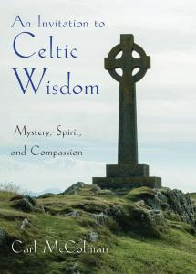I’ve been pondering the question, “What are the disctinctive qualities of Celtic Christianity?” In thinking about this, five particular points emerged. Celtic Christianity, as expressed in the poetry, prayers, folklore and hagiography of the earliest Christians of Ireland, Scotland and Wales, appears to have these five distinctive qualities:
- Hospitality, and particularly hospitality to all wisdom. This is epitomized by the early Celtic Christian tolerance/acceptance of the Celtic pagan past, at a time when most of Christendom was aggressively attacking all outsider religion as demonic. “Christ is my Arch-Druid,” said Columcille, implying not onlly his love for Christ, but that in Christ he could also honor the faith of his pre-Christian ancestors. I would think that today this hospitality manifests as a deep ecumenism and also as an openness to all that is beautiful good and true in non-Christian faiths, such as Vedanta or Zen. In general, the virtue of hospitality suggests that the heart of Celtic Christianity is an ethic of welcoming rather than purity.
- Deep love and respect for the earth. This is so obviously part of the heart of the Celtic tradition that it really needs no commentary. But from the folklore associated with saints like Kevin and Brigid, to the lorica attributed to Patrick, to the overall spirit of joy in nature found in early Celtic Christian poetry, this is a constant theme of Celtic wisdom, and one vitally relevant to our day. I don’t remember the exact quote, but Columcille once said something to the effect that the most fearful sound he could think of was that of an ax cutting down a tree. There is the Celtic heart.
- Honoring of women’s ministry. The archetype here is Brigid, the abbess who according to legend was consecrated a bishop and provided spiritual guidance to both women and me. In general, the role of women in early Irish law was much stronger and egalitarian than its Roman counterpart. I don’t want to overstate the case or suggest that Ireland was some sort of proto-feminist paradise, but I do think the relative standing of Celtic women when compared to women in general in the early centuries of Christianity can be an inspiration to all Christians who seek a more equitable theology of the sexes. The Celts remind us that we do not have to be limited by the heritage of the Roman Empire when it comes to understanding the role of women in the life of the church.
- Emphasis on the local. “To travel to Rome: great expense; little profit; but to pilgrimage to Glendalough: little expense, great profit.” Maybe this was just a marketing campaign launched by the good monks of Glendalough, but I think it speaks to a larger sensibility among the Irish (and other Celtic) Christians and general. Think of Holy Wells — each one is unique and different and distinctive. In the Celtic world, the local is just as important as the universal. Celtic Christianity balances universality with honoring of what is distinctive and unique about the locality. Closely aligned with this is the Celtic preference for monasteries rather than dioceses. The word “Tuath” suggests not only a community, but the land where that community lives. I think this goes a long way to explaining the Celtic spirit.
- Deep creativity. From the splendid illuminated calligraphy of the Book of Kells; to the intricate metalwork of the Ardagh Chalice; to the finely-crafted carving that characterizes the Crosses of Monasterboice: Celtic Christianity literally oozes with art and creativity. It’s a highly expressive tradition, full of poetry and folklore and local legends, and even “medieval bestsellers” like The Voyage of Brendan, rich with imaginative storytelling. This I would think is closely aligned with the love of the earth: to celebrate God’s creation is linked with celebrating our own creativity (and using it to honor and praise the Ultimate Artist).
I’m sure I could come up with more, but this seems to be a good place to stop for now.
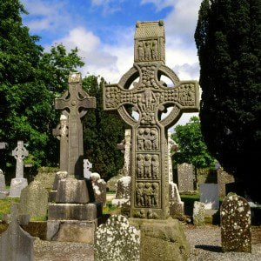(Photo credit: Shutterstock)It’s probably important to note that none of these distinctive qualities were universal in the Celtic church: for example, Kevin of Glendalough was notorious for his fear of women. But given the Celtic emphasis on the local, it’s important to remember that the world of Celtic spirituality is defined by diversity. What’s important is not that all Celtic Christians embodied hospitality, creativity, honoring of earth and women, and so forth; but that enough of them did so as to leave behind an inspirational literary tradition that embodies these values.
Celtic Christians never thought of themselves as somehow different or special. But by simply being themselves, they have bestowed upon us, their spiritual descendants, a priceless and precious gift: a unique way of looking at the world, and therefore, a distinctive cultural expression of discipleship that is deeply relevant to the needs of the postmodern world.
To learn more about Celtic spirituality, check out An Invitation to Celtic Wisdom: Mystery, Spirit and Compassion (Hampton Roads, 2018).

Celtic Spirituality: №2 — A Deep Reverence for Nature.



Andy Atwood
Follow
4 min read
·
Jul 13, 2024

Press enter or click to view image in full size
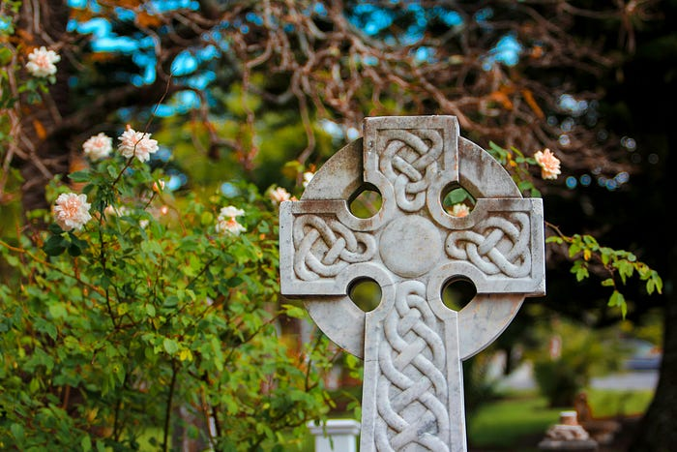
Photo by Sandy Millar on Unsplash
A deep reverence for nature is a central conviction in Celtic Spirituality. Creation is revelation. God’s presence permeates all of creation. Every single piece of it. Celtic Spirituality holds that the Divine is incarnate in all of creation.
It is rare for me to quote another at length, but here I go. Pelagius, who was identified as a heretic when I was in seminary many years ago, and who wrote around 400 CE, makes the point rather thoroughly, and in a voice that sounds like mine.
“Look at the animals roaming the forest: God’s spirit dwells within them. Look at the birds flying across the sky: God’s spirit dwells within them. Look at the tiny insects crawling in the grass: God’s spirit dwells within them. There is no creature on earth in whom God is absent. Travel across the ocean to the most distant land, and you will find God’s spirit in the creatures there. Climb up the highest mountain, and you will find God’s spirit among the creatures who live at the summit. When God pronounced that his creation was good, it was not only that his hand had fashioned every creature; it was that his breath had brought every creature to life. Look too at the great trees of the forest; look at the wild flowers and the grass in the fields; look even at your crops. God’s spirit is present within all plants as well. The presence of God’s spirit in all living beings is what makes them beautiful; and if we look with God’s eyes, nothing on earth is ugly.” (CCP)
Beautiful. Thoroughly and profoundly beautiful.
Yet, I can imagine a conversation between Pelagius and Albert Einstein in which there is a challenge to move beyond “living beings” to consider all of creation, even inanimate creation. Matter is energy, and matter matters deeply. God’s spirit, Einstein might argue, is the energy that is manifested in the whole universe!
I’m reminded of an article I wrote about Albert Schweitzer, the Nobel Peace Prize winner, physician, musician, missionary, and theologian. Picture the three of them. Pelagius, Einstein, and Schwitzer — together, talking and listening to each other’s inner wisdom.

Reverence for Life — Albert Schweitzer’s Core Ethical Principle

Today, my passion is focused on Loving Mother Earth. Some of the energy that drives me today was birthed by a…
medium.com

In an age where we are confronted with the environmental disasters that we have created, Celtic Spirituality brings us back to what we know to be true deep in our souls.
Mother Earth is to be revered. Celtic Spirituality has a theology, a cosmology, that supports such a belief.

The suchness of nature, its very being, has everything to teach us about how to live in harmony.

Mother Earth is our great teacher.
Here are a couple of “fun facts,” as we call them in our home.
First, while religious Scripture is important as a source of knowledge, in the Celtic tradition, Scripture is meant to inform us about nature and the natural order. A theologian might say specific revelation is meant to inform us about general revelation. They are both useful.

Second, when in nature, when “Forest Bathing,” we are within the temple of the Divine. Celts worshiped not in basilicas but in nature, or small churches close to nature.
Third, as John Scotus Eriugena wrote in the 800's: “We should not therefore understand God and creation as two different things, but as one and same. For creation subsists in God, and God is created in creation in a remarkable and ineffable way….” (CCS). This sounds a lot like panentheism, the belief that the Divine is within and between all of creation, and beyond.

Here is a take away for you.
Look about you right now. Everything you see, every single thing, is a manifestation of God. For those of us from the Christian tradition, we would say Christ is within and between all.
Look in the mirror. Same thing. A manifestation of the Divine.

May we live with a deep reverence for nature; a deep reverence for all of life.

A deep reverence for your life.
NOTE: I have written an Introduction, and will write 20 articles on Celtic Spirituality. I won’t write in order, but I’ll get to all 20… and more.

Celtic Spirituality: A Relevant Refreshment for Today’s World

20 convictions that define Celtic Spirituality. One or more might grab your heart.
medium.com

Celtic Spirituality: A Relevant Refreshment for Today’s World



Andy Atwood
Follow
4 min read
·
Jun 4, 2024
61
1

Press enter or click to view image in full size
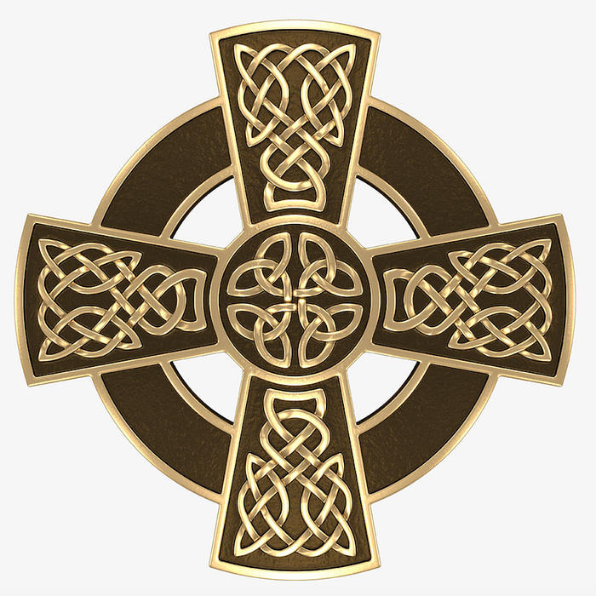

20 convictions that define Celtic Spirituality. One or more might grab your heart.
While looking for a new space to call home, and visiting many available listings, I walked through the door of one dwelling and instantly felt it. My qualifying criteria were satisfied, and my inner knowing just perked up…. This is it! This is where I want to live!
Well, that’s what happened when I read John Philip Newell’s book, Sacred Earth-Sacred Soul: Celtic Wisdom for Reawakening to What Our Souls Know and Healing the World.
In fact, I read the book twice, marked it all up, and typed a 15-page outline. Then I bought other books, original source material, researched online, and talked with friends about my realization. The deeper I went, the more I fell in love with my new home.
Evangelical Christianity has been my old home for decades, but no longer. It became rather stale and is now, frankly, an embarrassing mess. I simply outgrew the confines of my solid Christian, Protestant, Calvinistic, Evangelical, and Socially Progressive upbringing.

In Celtic Spirituality I have found a more relevant home for my evolved beliefs and practices.

Here are the 20 convictions that define Celtic Spirituality.
Listen to your soul as you read and notice if you are drawn to any of these convictions.
- Deep within each of us is an inner wisdom — and it is trustworthy. While you read on, notice those moments when you say to yourself… “I know this is true.”
- A central conviction is in having a deep reverence for nature. Creation is revelation. God’s presence permeates all of creation. Every single piece of it. Celtic Spirituality holds that the Divine is incarnate in all of creation.
- You can see this depicted in the Celtic Cross with its circle and interwoven designs. Everything is interwoven with everything else. There is a Oneness that threads through it all.
- Staying grounded in our Original Blessing. Rather than succumbing to a dualistic good/bad perspective, the emphasis in Celtic Spirituality is on the interconnectedness of all beings, including humans, with the natural world and the Divine.
- The lines between sacred and secular are blurred. The Divine presence that permeates everything does truly and deeply integrate it all.
- Worship happens in nature, not just in a church building.
- Centers for contemplation and learning are common. There are places where solitude can be experienced, within community or outside of it.
- Personal and communal practices are meant to deepen one’s experiences of the presence of the Divine in all of life.
- Art, poetry, and music are highly valued as expressions of one’s deep experiences with the Holy.
- Sexuality is celebrated as a natural part of life and living.
- A focus on the Trinity, on the relationship between all things, is uplifted. It is not just the pieces of creation, but their relationship with one another that is uplifted.
- Actual pilgrimages exemplify the journey of life. In this tradition, getting up and going to a sacred place to experience the movement of the spirit is a common practice.
- We stray while on the pilgrimage of life, and straying marks the path. Life, in all its varied colors, is to be robustly experienced. Errors are called out, noted, and corrected as one calmly carries on.
- Soul friendships, spiritual friendships, are honored as necessary for the journey of life. One travels furthest with an accountable, soulful companion with whom everything is shared.
- Liminal space is attractive. Thresholds are noticed. There, in the thin places, on the shore between this and that, ambiguity is embraced as would be a Zen koan. Paradoxes and polarities and dilemmas are fertile sources for growth.
- What is being sought is the integration of everything in the Divine. Home, Source, Essence, the Creator… God by whatever name. Stretching beyond dualism, beyond black and white, what is sought is an integration of all that is into One.
- Male and female, in their various forms, are integrated and given equal status. Gender equality is acknowledged.
- We can experience God’s presence through sacred scriptures, and through the natural world. Both are valued as sources of revelation.
- It is one’s mission to love the natural world as a natural consequence of a natural faith.
- Hospitality is extended generously to all beings, for all are incarnations of the Divine.
There you have it. Admittedly, an incomplete list of 20 convictions that are associated with Celtic Spirituality.
I’ll be writing on each of the 20, and more. If you are so inclined, Follow Me or Subscribe to my Medium articles. My thesis is that Celtic Spirituality provides a path and a practice that is especially relevant to the changing environment in which we are presently living.

Celtic Spirituality: № 14 — Soul Friends

Andy Atwood
Follow
3 min read
·
Jul 24, 2024
4

Press enter or click to view image in full size
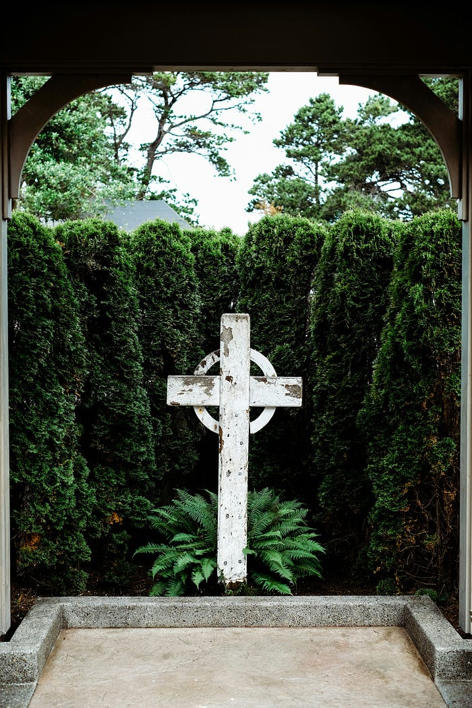
Photo by Josh Applegate on Unsplash
There is nothing as peaceful as being in a relationship with another soul that has at its core a deep give and take of gracious love.
In Celtic Spirituality that uniquely precious relationship is the one you have with your Anam Cara — your Soul Friend.
Such a loving friendship extends a free and unmerited acceptance of one’s whole self — and in that the Eternal is awakened.
One of the very first books I read as a budding psychotherapist was Truax and Carkhuff’s Toward Effective Counseling and Psychotherapy: Training and Practice. In fact, part of their work was the focus of my master’s dissertation.
These two gentlemen did a lot of research around effective relationships. The most profoundly helpful therapeutic relationships they found, were not casual or transitory, but were characterized by three attributes: accurate empathy, non-possessive warmth, and genuineness.
- Accurate empathy is about connecting around feelings and emotions with matched intensity.
- Non-posssessive warmth is about the free and unmerited grace that is extended toward each other.
- Genuineness is about being real, authentic and transparent with each other.

Whether someone is a highly trained clinician, or simply an old neighbor or mate, Soul Friends have these same three traits — and a very special something else.
Most recently, as I have awakened to the relevance of Celtic Spirituality, I have been amazed to learn about how common, and how important it is to have a Soul Friend.
With your Soul Friend, you are totally open and vulnerable in a way that cuts across traditional conventions. Your Anam Cara, your Soul Friend, creates a relationship with you that is full of accurate empathy, non-possessive warmth, and genuineness — and that very relationship of mutuality is a hothouse for spiritual growth. Right there is where that “very special something else” is experienced as the presence of the Divine within and among you. Your relationship is know to be sacred.
John Cassian, the 4th Century Monk, captured yet another feature of the essence of a relationship between Soul Friends when he wrote: “This, I say, is what is broken by no chances, what no interval of time or space can sever or destroy, and what even death itself cannot part.”
Imagine, a friendship with the Divine Presence that is eternal.
When reading and reflecting on the Anam Caras in my own life, I went back to that dissertation I wrote decades ago, which focused on the similarity between non-possessive warmth and grace.

I could see the thread running through my life, the thread of relationships that have been full of empathy, grace, and profound honesty.
Admittedly, I’ve been an imperfect friend. Yet, in those relationships where our imperfect souls have met each other with empathy, non-possessive warmth, and genuineness… we both have thrived.
A Soul Friendship is inherently healing and nurturing.
Here again is that very special something. Your relationship with your Anam Cara has a larger Divine purpose way beyond ego gratification.

“With your Anam Cara you awaken the eternal.”
So writes John O’Donohue in his wonderful book, Anam Cara: A book of Celtic Wisdom.
This very special relationship exists to glorify God by awakening God’s presence within and between each of you.
If you have an Anam Cara and you know it, let him or her read this article. Affirm your relationship and see it for what it is — the loving presence of the Divine manifesting love into this world through your relationship with each other.
My hope is that you will be Present with your your Soul Friend, your Anam Cara in infinite love and great gratitude.
This article is one of more than 20 that I am writing on Celtic Spirituality, each of which is intended to awaken you.

Celtic Spirituality: A Relevant Refreshment for Today’s World

20 convictions that define Celtic Spirituality. One or more might grab your heart.
medium.com

ABOUT ME? I am a Christian by heritage, and yet an emerging human being who is now embracing Celtic Spirituality. Further, I am an environmentally concerned citizen, a semi-retired psychotherapist, and an ordained clergyman who continues as a Pastoral Counselor. I am also a friend. Our family tends 120 acres of forest in Michigan.

12 Celtic spiritual practices to celebrate God in our world
Renew your spiritual life and community worship with these adaptations of ancient Christian practices.
Our Faith
Christine Valters Paintner
Published May 21, 2019
Celtic Christian spirituality refers to a set of practices and beliefs in Ireland, Scotland, and Wales that developed in the early fifth century during the development of the monastic tradition. Many of these practices have roots in desert spirituality; Celtic monks considered the teachings of the desert mothers and fathers essential wisdom.
Celtic pre-Christian culture, dating back to 500 B.C.E., permeated the land, and these beliefs also strongly influenced Celtic spiritual practices. As a result, much of Celtic Christianity can be characterized by a strongly incarnational theology: The natural world, in particular, reveals the sacramentality of all creation. Matter is infused with the divine presence and offers glimpses of the world behind the surface of things. This spirituality celebrates the human imagination, cultivating creativity through various art forms such as manuscript illumination and vibrant metalwork.
There has been a recent strong revival of interest into Celtic Christianity as a way to renew our spiritual lives and community worship. What follows is an exploration of 12 Celtic Christian practices for modern Catholics’ daily spiritual lives, along with scripture passages for meditation.

1. Thresholds
Thresholds are the spaces between when we move from one time to another, as in the threshold of dawn to day or dusk to dark; from one space to another, as in times of pilgrimage or in moving from secular to sacred space; and from one awareness to another, as in times when old structures start to fall away and we begin to envision something new.
Advertisement

The Celtic peoples had a love of edges and boundary places, most likely as the result of living on an island, but they also held a keen sense of the Otherworld as a place just beneath the veil of this one.
Celtic Christian monks were also drawn to edge places, inspired by those who fled to the desert. They found their own threshold places, such as Skellig Michael, a jagged stone island jutting out into the Atlantic on which the ruins of a monastic community are still perched on top.
In daily life
Become aware each time you cross a threshold. This might be across a doorway, in moving from one activity to another, or the thresholds of the day, especially at dawn and dusk. Pause at each of these and offer a short prayer of gratitude.
Advertisement
Scripture meditation
Thus says the Lord:
Stand at the crossroads, and look,
and ask for the ancient paths,
where the good way lies; and walk in it,
and find rest for your souls.
—Jeremiah 6:16

2. Dreams
In ancient times dreams were respected as signs from God. Dreams play a significant role in scripture, with guidance and direction often arriving in these night visions.
Joseph of the Hebrew Bible, Jacob’s dream of a staircase from earth to heaven with angels ascending and descending, Daniel’s dream of the four beasts, and Joseph the father of Jesus’ four separate dreams are all notable examples from scripture.
Advertisement
Many Irish saints had meaningful dreams as well. Legend says St. Patrick had a dream in which he was visited by an angel who encouraged him to flee captivity and helped arrange a miraculous escape. He later had another dream in which he heard the Irish people calling out to him to return to the land of his enslavement and help Christianity flourish.
In daily life
One of the best ways to remember your dreams is to place a journal and pen by your bed at night and then ask God for a dream before sleep. Even if you awaken with only a fragment or a feeling, record that upon waking.
Scripture meditation
Advertisement
Now after they had left, an angel of the Lord appeared to Joseph in a dream and said, “Get up, take the child and his mother, and flee to Egypt, and remain there until I tell you.”
—Matthew 2:13

3. Peregrinatio pro Christo
In the Celtic monastic tradition, wandering was a powerful practice inspired by the biblical story of Abraham. There is a unique term for this wandering: peregrinatio pro Christo, or the call to wander for the love of Christ. It differs from pilgrimage and is a phrase without a precise English definition.
Advertisement
The wandering saints set forth without destination, often getting into a small boat with no oars or rudder, called a coracle, and trusting themselves to the currents of divine love.
They surrendered themselves completely to the wind and ocean and let themselves be carried to what they called the place of their resurrection, the place where they would live and work, die and be buried, and where their remains would await their resurrection on the Last Day.
Advertisement
In daily life
Each evening reflect on the previous day and notice the signs of the divine presence. Where have you felt nudges to move forward? How have you been invited to surrender into trust? Where have you turned away from these? In what ways did you resist or ignore the holy impulses?
Scripture meditation
When Abram was ninety-nine years old, the Lord appeared to Abram, and said to him, “I am God Almighty; walk before me, and be blameless. And I will make my covenant between me and you, and will make you exceedingly numerous.”
—Genesis 17:1–2

4. Blessing each moment
In the Celtic tradition, one of the practices that aids in loving attention to daily life is blessing. Blessings are prayers celebrating the ordinary tasks of the day. There is a beautiful book of Scottish blessings called the Carmina Gadelica, collected by Andrew Carmichael in the 19th century in Scotland’s Outer Hebrides. It is filled with blessings of the day’s unfolding.
Blessing is an act of acknowledging the gifts and graces already present and offering gratitude to God for them. All the mundane activities of the day are opportunities to witness grace at work.
In daily life
We can begin to see the everyday things of our lives as openings into the depths of the world. The steam rising from my coffee, the bird singing from a tree branch outside my window, the doorbell announcing a friend’s arrival, the meal that nourishes my body for service all bring me closer to God’s grace. Consider writing a blessing of gratitude for each of the ordinary things that sustain you during the day.
Scripture meditation
God said, “This is the sign of the covenant that I make between me and you and every living creature that is with you, for all future generations: I have set my bow in the clouds, and it shall be a sign of the covenant between me and the earth.”
—Genesis 9:12–13

5. Soul friendship
Another key practice for the Celtic saints was having a soul friend, inspired by earlier desert traditions. St. Brigid is often quoted as saying, “Go forth and eat nothing until you get a soul friend, for anyone without a soul friend is like a body without a head; is like the water of a polluted lake, neither good for drinking nor for washing.”
Everyone, whether lay or clergy, man or woman, was expected to have a spiritual mentor and companion on the soul’s journey. This was a person in whom they could confide all of their inner struggles, someone who would help them find their path and who could midwife them in discernment. There was a sense of genuine warmth and intimacy in this relationship and deep respect for the other’s wisdom as a source of blessing. Age or gender differences did not matter.
In daily life
I invite you to spend some time seeking out a soul friend. You may already have one in your life: a spiritual director, a wise guide, someone you can turn to when things feel challenging and to whom you entrust the secret desires of your heart.
Scripture meditation
Do not press me to leave you
or to turn back from following you!
Where you go, I will go;
where you lodge, I will lodge;
your people shall be my people,
and your God my God.
—Ruth 1:16

6. Encircling
Christ with me, Christ before me
Christ behind me, Christ in me
Christ beneath me, Christ above me
Christ on my right, Christ on my left
Christ when I lie down, Christ when I sit down
Christ when I arise, Christ to shield me
—Prayer excerpt attributed to St. Patrick
In the Celtic monastic tradition, a lorica is a type of prayer seeking protection, invoking the power of God to safeguard against darker forces. You are probably familiar with the lorica prayer above, attributed to St. Patrick. The biblical inspiration may come from Ephesians 6:14, which refers to putting on the breastplate of righteousness.
This practice is rooted in the precarious sense people often have of our own existence. Travelers especially faced dangers at night from thieves or wild animals with only fire and prayer as protection.
In daily life
These breastplate prayers name the presence of Christ in all directions as a shield against harm and a reminder of God’s loving presence. You can extend this circle beyond yourself to include your family, your community, your country, and the earth.
Scripture meditation
You who live in the shelter of the Most High,
who abide in the shadow of the Almighty,
will say to the Lord, “My refuge and my fortress;
my God, in whom I trust.”
—Psalm 91:1–2

7. Walking the rounds
A central Celtic practice at sacred sites, such as churches, graves, crosses, and holy wells, is known as “walking the rounds.”
This involves walking sunwise (or clockwise) in a mindful way around various markers or monuments. The number of rounds varies but is often three to reflect the sacredness of that number in the Celtic imagination. There are pattern days associated with different holy places and a set number of rounds to walk in specific places along with certain prayers.
Walking helps to arrive to a place and slow down. Walking in a circular manner helps to move us out of linear ways of thinking and to open our hearts to receive God’s grace.
In daily life
Find a holy place to walk around. It might be a sunwise journey around a favorite tree, your church, or around the edges of a labyrinth. While walking the rounds, you might say traditional prayers like the Hail Mary and the Lord’s Prayer, but any prayers of the heart are welcome.
Scripture meditation
When the Lord saw that he had turned aside to see, God called to him out of the bush, “Moses, Moses!” And he said, “Here I am.” Then he said, “Come no closer! Remove the sandals from your feet, for the place on which you are standing is holy ground.”
—Exodus 3:4–5

8. Learning by heart
While the Irish monks are known for their illuminated sacred texts, books were rare and valuable, so they would have had to learn many scripture passages by heart to be able to pray with them. This was a continuation of the older Druidic tradition, which was primarily an oral culture that prized memorization rather than writing.
The Irish monks sang psalms throughout each day as a central part of their prayer. They were immersed in this poetry and ancient call to see God active in the whole world. They likely would have memorized all 150 psalms, as their days were intertwined with their imagery.
In daily life
Begin by finding just two lines of a scriptural text or poem that are meaningful to you. It could even be one of the suggested texts in this article. Spend time each morning with these lines, repeating them gently to yourself until you have learned them by heart and then recall them throughout the day.
Scripture meditation
I will put my law within them, and I will write it on their hearts; and I will be their God, and they shall be my people.
—Jeremiah 31:33

9. Solitude and silence
The desert tradition profoundly influenced the Celtic monks; while many monks were unable to go to the literal desert, they sought out the wild edges and solitary places of wilderness.
There are many sacred places in Ireland and Wales with the word dysert or disert in the name. This is the Irish word for desert and refers to a place of solitude and silence, a retreat for those who long for a more intimate encounter with God and where attention can be cultivated with few distractions.
There are many stories of Irish monks who lived as hermits for a time, including Sts. Colman and Kevin, who both lived in caves and had animals as their companions.
In daily life
Begin by making a commitment to spending 5–10 minutes each day in silence. Turn off any notifications from your phone or computer and ask others in your house not to disturb you. Then extend this by finding a whole morning or afternoon to go to a nearby retreat center or monastery and listen deeply to the sacred stirrings within.
Scripture meditation
Then God spoke all these words: I am the Lord your God, who brought you out of the land of Egypt, out of the house of slavery; you shall have no other gods before me.
—Exodus 20:1–3

10. Seasonal cycles
The unfolding of the seasons was an overarching template for the Celtic imagination. In the pre-Christian tradition there are significant feast days aligned with the equinoxes and solstices. And then there are the cross-quarter days, which are the midway points between them and part of the harvest cycle.
The Christian calendar incorporates many of these rhythms, with Christmas falling near the winter solstice, the feast of John the Baptist at the summer solstice, and Easter after the spring equinox. The monastic prayers of the Liturgy of the Hours also respects these sacred rhythms of nature’s rise and fall, birth and death.
In daily life
Make time for contemplative walks outside in your neighborhood. Instead of trying to get somewhere specific, simply pay attention to the world around you and how God might be speaking to you. Pay particular attention to the signs of the season—what flowers might be in bloom, whether the trees have their leaves, and the height of the sun in the sky. Ask yourself what season your own soul is in right now.
Scripture meditation
For everything there is a season, and a time for every matter under heaven: a time to be born, and a time to die.
—Ecclesiastes 3:1–2a

11. Landscape as theophany
The Celtic imagination considers sacred places to be “thin,” or places where the veil between the worlds, meaning heaven and earth, seem especially near to each other.
Ninth-century Irish theologian John Scotus Eriugena taught that there are two books of revelation: the book of the scriptures and the book of creation. Both are required to know the fullness of the divine presence.
Just as God can speak through the words of the scriptures, so can we hear the voice of the divine in the elements and in creatures. The landscape can become a theophany, or place of divine manifestation. The Celtic monks sought out places in the wilderness to receive this gift of revelation.
In daily life
Make a commitment in the coming days to spend time in nature and be present to it as a place of revelation. Bring the prayers of your heart and ask God for signs and symbols to guide you on the way. Consider making a pilgrimage to a landscape that feels especially sacred to you, whether desert, mountain, sea, river, or plains.
Scripture meditation
“Go out and stand on the mountain before the Lord, for the Lord is about to pass by.” Now there was a great wind, so strong that it was splitting mountains and breaking rocks in pieces before the Lord, but the Lord was not in the wind; and after the wind an earthquake, but the Lord was not in the earthquake; and after the earthquake a fire, but the Lord was not in the fire; and after the fire a sound of sheer silence.
—1 Kings 19:11–12

12. Three essential things
Three is a sacred number in the Celtic tradition, and often the saints expressed their own desires or commitments in terms of the number three.
St. Columba of Iona asked God for three things: virginity, wisdom, and pilgrimage. St. Ita of Killeedy focused on faith, simplicity, and generosity. Each is a variation on wisdom for the three essential things one must do in life.
None of the monks say the same three things, which open us up to the possibility that what is essential to one person will be different to another. Similarly in different seasons of life, what is essential for us might change.
In daily life
Reflect on the three things in your own life you count as most essential. Hold them as principles or touchstones for your life right now as you continue your spiritual journey. One way to do this is to imagine you are at the end of your life looking back. For what do you want to be remembered?
Scripture meditation
He has told you, O mortal, what is good;
and what does the Lord require of you
but to do justice, and to love kindness,
and to walk humbly with your God?
—Micah 6:8

Videos and Podcasts on Celtic Spirituality, Thresholds, Thin Places

https://www.youtube.com/watch?v=lZDycqZl79I&t=31s historical development of Celtic Spirituality
https://www.youtube.com/watch?v=DONuyLwWPaY I Arise Today video Rita Connolly

