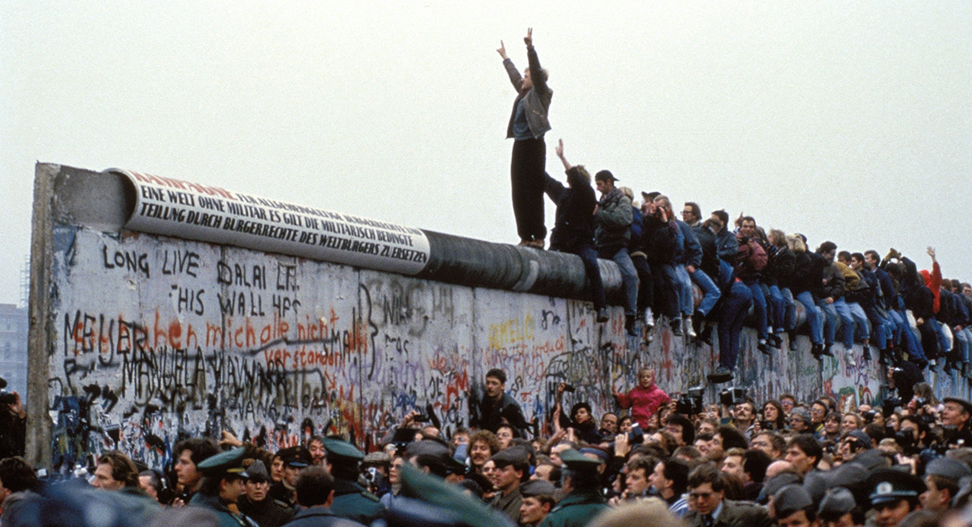

Getty Images

[**2016**](https://www.politico.com/magazine/tag/2016)

**The World Is Full of Walls That Don’t Work**

Why would Donald Trump want to build another one?

By MICHAEL DEAR

August 16, 2016

Continue to article content

* [**Facebook**](http://api.addthis.com/oexchange/0.8/forward/facebook/offer?pco=tbx32nj-1.0&url=https://www.politico.com/magazine/story/2016/08/donald-trump-2016-wall-wont-work-214167&pubid=politico.com/magazine)
* [**Twitter**](http://api.addthis.com/oexchange/0.8/forward/twitter/offer?pco=tbx32nj-1.0&url=https://www.politico.com/magazine/story/2016/08/donald-trump-2016-wall-wont-work-214167&text=The%20World%20Is%20Full%20of%20Walls%20That%20Don%E2%80%99t%20Work&pubid=politico.com/magazine&via=politicomag)
* [**Email**](mailto:?to=&subject=The%20World%20Is%20Full%20of%20Walls%20That%20Don%E2%80%99t%20Work&body=https://www.politico.com/magazine/story/2016/08/donald-trump-2016-wall-wont-work-214167)
* [**Comment**](https://www.politico.com/magazine/story/2016/08/donald-trump-2016-wall-wont-work-214167#superComments)
* [**Print**](https://www.politico.com/magazine/story/2016/08/donald-trump-2016-wall-wont-work-214167)

Continue to article content

**THE FRIDAY COVER**

[](https://www.politico.com/magazine/story/2019/02/15/congress-house-democrats-freshmen-mikie-sherrill-aoc-225054)

[**Read more**](https://www.politico.com/magazine/story/2019/02/15/congress-house-democrats-freshmen-mikie-sherrill-aoc-225054)

*Michael Dear is emeritus professor in the College of Environmental Design at the University of California, Berkeley, and author most recently of Why Walls Won’t Work: Repairing the US- Mexico Divide (2015, Oxford University Press).*

Across the world, building walls has become the political strategy favored by nations convinced that barriers are the only way to deal with difficult neighbors. In [some](http://www.politico.com/magazine/story/2016/04/georgia-border-russia-vladimir-putin-213787) regions, walls are used to claim territory; in [others](http://america.aljazeera.com/articles/2014/3/12/visual-activism-activestillsphotographsthebarrierwall.html), they are used to separate warring factions; in yet [others](https://www.washingtonpost.com/news/worldviews/wp/2015/08/28/map-the-walls-europe-is-building-to-keep-people-out/), they are meant to keep the unwanted out.

Donald Trump shares this view. The centerpiece of his presidential platform from the beginning has been building a wall between Mexico and the United States to stop illegal immigration, getting Mexico to pay for the concrete structure, and outlawing amnesty for immigrants already in the U.S. without documentation. (He presents this as a new initiative, without mentioning that the U.S. has just completed building 651 miles of fencing and walls along our southern border.)

But what Trump doesn’t understand—ironic, for someone so preoccupied with “winning”—is that building walls between nations is an utter failure of the geopolitical imagination. Walls are a blunt instrument of diplomacy. At best, they offer temporary respite from deeper tensions which usually remain unresolved by separation. At worst, walls can exacerbate the problems they were intended to solve. Put simply, walls do not work as permanent solutions to tough problems. Which is why, ultimately, they fall.

Trump is not alone in his obsession with border fences. In the decade following 9/11, the number of walls being built globally doubled, rising to almost 50 today. This new “world of walls” materialized in response to uncertainties following the breakup of the Cold War order, the emerging war on terrorism, and global migrations caused by violence, persecution, poverty and hunger. Fences were being erected to keep refugees out of Europe, to keep citizens in North Korea and to secure territorial gains everywhere. The international geopolitical playbook seemed dominated by a single strategy: Whenever two or more opposing factions clash, separate them by building a wall. A later corollary was added: Don’t hesitate to build your walls in other countries if by doing so you can prevent migrants from getting into your country in the first place (as Australia did in Papua New Guinea).

[160718_ioffe_melania.jpg](https://www.politico.com/magazine/story/2016/07/2016-donald-trump-mexico-us-border-patrol-immigration-undocumented-illegal-customs-texas-rio-grande-214060)

[**2016**](https://www.politico.com/magazine/tag/2016)

[**Donald Trump’s Army on the Border**](https://www.politico.com/magazine/story/2016/07/2016-donald-trump-mexico-us-border-patrol-immigration-undocumented-illegal-customs-texas-rio-grande-214060)

By GARRETT M. GRAFF

It’s not that walls completely lack purpose or value. For instance, installing barriers to staunch the current flood of refugees into Europe could be one way of providing temporary relief to host country agencies. Or, using walls to establish a cease-fire zone separating the belligerents in Syria could diminish conflagrations between warring factions long enough to enable a peace to be negotiated. But these are temporary fixes, necessary when a more comprehensive solution is unworkable. Separation barriers by themselves cannot stem the migration impulse, or remove the cause of war; they are fundamentally a way to postpone making larger and more difficult policy decisions.

Sometimes, barriers can even make things worse. When a wall is built and a lasting solution postponed, its builders run the risk that the temporary fix will aggravate the problem it was designed to alleviate. After all, when a barrier becomes an established feature of the geopolitical landscape, it often offers a rallying point for unresolved tensions, becoming a suppurating wound causing perpetual irritation.

These are all problems that the past 100 years of wall-building clearly demonstrate—and that three specific examples (Israel/Palestine, East and West Berlin and the U.S.-Mexico border) put into relief. It’s a history that Trump and his supporters would do well to consider before calling in the construction crews.

ADVERTISING

**Israel/Palestine**

In its modern form, the conflict between Palestine and Israel was born during the British mandate of Palestine following World War I. In 1917, the so-called Balfour Declaration informed Zionists in search of a national homeland that the British government viewed with favor “the establishment in Palestine of a national home for Jewish people.” However, this statement was immediately qualified when it also advised that “nothing shall be done which may prejudice the civil and religious rights of existing non-Jewish communities.” This diplomatic sleight of hand simultaneously legitimized the claims of both Israel and Palestine—and helped usher in a century of confusion and bloodshed.

Almost immediately, there were problems. Arab nations were resolutely opposed to any kind of negotiations on anything (territorial or otherwise) with Israel; and Israel was not about to surrender the toehold that the Balfour Declaration had offered. Disputes over the dimensions of partition for separate Palestinian and Israeli states lingered until the United Nations produced its own plan for a political settlement in 1947, granting territory to form a new state of Israel. Less than a year later, the first Arab-Israeli war broke out, and in one form or another, the battles have continued ever since.

[160722-trump-speech-ap-1160.jpg](https://www.politico.com/magazine/story/2016/07/the-exact-type-of-immigrant-we-want-214087)

[**LETTER FROM CLEVELAND**](https://www.politico.com/magazine/tag/letter-from-cleveland)

[**‘The Exact Type of Immigrant We Want’**](https://www.politico.com/magazine/story/2016/07/the-exact-type-of-immigrant-we-want-214087)

By JULIA IOFFE

Today, rather than try to forge a lasting peace with an official demarcation of Israeli and Palestinian states, Israel is constructing walls around Palestinian-occupied territories. Israel claims these walls are to protect its citizens from attack. Palestinians counter that this separation barrier is cover for an Israeli attempt to establish de facto territorial limits for a future partition between the two states. From a Palestinian viewpoint, the building of walls by Israelis in disputed territory is simply deepening the crisis, and pushing a peaceful agreement between the two sides further into the future. The wall, in other words, is just adding fuel to the political fire. And as for trying to stop the bloodshed? This summer saw a [new wave](https://www.theguardian.com/world/2016/mar/31/israel-palestine-violence-knife-attacks-west-bank-gaza)of violence in the region.

**East Berlin/West Berlin**

At the end of World War II, Germany was divided into east and west regions, reflecting the respective influences of the Soviet Union and the Euro-American alliance. Germany’s capital city, Berlin, located in East Germany, was also divided into east and west sectors. Sixteen years later, in 1961, migration from East to West Berlin had become so voluminous that East Germany constructed a militarized and fortified barrier zone (composed of multiple walls and fences) across the city to prevent unregulated movement between the two sectors.

The wall was intended to stem the flow of migrants. But it did nothing to solve the deeper problems that were causing the exodus from East Berlin in the first place: a repressive, authoritarian regime that brooked no dissent; and drastically declining standards of living for ordinary citizens who were able to observe the spectacularly successful West German economic recovery simply by looking out their windows. If anything, the wall worked against the Soviet Union, because the West turned it into a powerful symbol of communist oppression, especially when East German guards began killing those trying to cross to West Berlin.

The Berlin Wall remained for 28 years, until 1989. It wasn’t until Soviet influence declined that political support for the wall began to erode. Finally, one night, a combined assault by citizen demolition crews and avid souvenir hunters began tearing down the Wall, allowing Easterners to cross once more without hindrance.

**United States/Mexico**

One of the most prominent new walls of the 21st century is the newly erected barrier between the United States and Mexico.

The 1848 Treaty of Guadalupe Hidalgo ended the Mexican-American War and was followed by a six-year effort to survey and mark the boundary line between the two nations. Initially, only 52 boundary monuments marked the 2,000-mile boundary, and during the next 140 years, the line was by and large casually observed. It wasn’t until the 1990s that the first fences appeared in major border cities, aimed at stopping the flow of migrant labor from Mexico. But after 9/11, the U.S. government launched a full border fortification program, imposing an unprecedented degree of separation along most of the land boundary.

Over the past 10 years, a total of 651 miles of fortifications have been erected, primarily along the land boundary. They consist of vehicle and pedestrian barriers, supplemented by a high-tech “virtual” surveillance border. The 651 miles were regarded as the maximum length of feasible wall-building, since in many places the terrain was so steep that construction was impossible, and fence construction across reservoirs and other water boundaries was not viable.

Has the border wall worked? Did it help stop undocumented immigration? Well, it turns out that it’s hard to prove that it did.

The U.S. government collects information on many immigration indicators, but no one explicitly measures the volume of undocumented border crossings, or the extent to which the Mexican border is in fact “secure.” We do know that apprehensions fell and deportations rose to a record level in recent years, and consequently, the unauthorized migrant population in the U.S. fell from 12.4 million in 2007 to 11.1 million in 2011. What no one can conclusively prove is how much the 651 miles of wall contributed to this decline in undocumented population in the U.S. About five years ago, the U.S. Department of Homeland Security began saying that the wall was never intended to stop people from crossing, but merely to slow them down so they could more easily be apprehended by conventional methods. So, could it be that doubling the number of U.S. Border Patrol agents to more than 20,000 was a more important factor in achieving these results?Other possible causes mentioned as contributing to the decline included: rising deaths and injuries incurred by border crossers, as well as spiraling costs of assisted border passages; declining job opportunities caused by economic recession in the U.S.; and improvements in the Mexican economy. In a nutshell: undocumented migration into the U.S. is at its lowest level since the 1970s; deportations are at the highest levels ever; but the contribution of the walls and fences in achieving these results cannot even be measured, still less proven.

[150708_arellano_trump_ap.jpg](https://www.politico.com/magazine/story/2015/07/donald-trump-mexicans-119849)

[**2016**](https://www.politico.com/magazine/tag/2016)

[**Donald Trump’s Wrong. Mexicans Aren’t Going to Rape You.**](https://www.politico.com/magazine/story/2015/07/donald-trump-mexicans-119849)

By GUSTAVO ARELLANO

Meanwhile, this dubiously effective physical structure has wreaked havoc in communities where it is located, on both sides of the border. The collateral damage has included the costs of delays and congestion at border crossings suffered by trading partners and commuters alike; environmental damage and destruction caused by the construction; interruptions in the daily lives of school children, families and friends whose lives depend on daily crossings; the massive impositions of the security apparatus that has turned the border zone into what Arizona residents describe as a “police state”; and the deep and lasting resentment that the wall has generated in Mexico. Just ask those who live near the wall: A majority of border residents on both sides say they do not want more walls, preferring that money be spent on upgrading ports of entry at the border line.

So, would the second wall promised by Donald Trump have the same inconclusive results and negative collateral impacts as the first?

At this point, it’s certainly not likely have much of an impact on undocumented immigration. Federal immigration policy has already shifted attention away from the border zone to the U.S. interior, enforcing employment practices, and pursuing the large number of undocumented who overstay their visas.

Truth be told, the wall is more likely to make things worse. It will risk even greater disruption to connections between cross-border communities, increase environmental destruction by building of new fortifications, elevate congestion costs and delays that inhibit binational trade, and further insult and antagonize diplomatic relations with Mexico.

The concept of a “wall” may sound good in political rallies. It purports to identify a source for the country’s ills; it plays on fear-driven nativist sentiments; and it recommends action to solve the problem, however imprecisely the problem is understood. But if you’re looking for effective policy, stay away from building more walls. For centuries, walls have not worked, and ultimately, they always come down.